Data Analysis/Sensors Beginner Guide

**Data Analysis/Sensors Beginner Guide**

## ***To Begin With***

Here is a list of functionalities that will be helpful to know (in order of priority) on Excel:

1. basic formulas (min, max, sum, count, countif, if, etc)
2. filter
3. sorting
4. conditional formatting
5. group by view

After you get to know Excel, try doing the following!

## ***Tutorial Summary***

This generates a sample table for the Slider Minimum and Maximum Values, as well as the total # occurrences of the sliders per participant.

Finishing this tutorial should give you a basic idea of:

1. How to use the formulas
2. How to automate the table through VBA
3. How to automate the table for multiple CSV files at once through VBA

### **Decomposing the Code:**

### 

(top of the SliderData CSV Files)

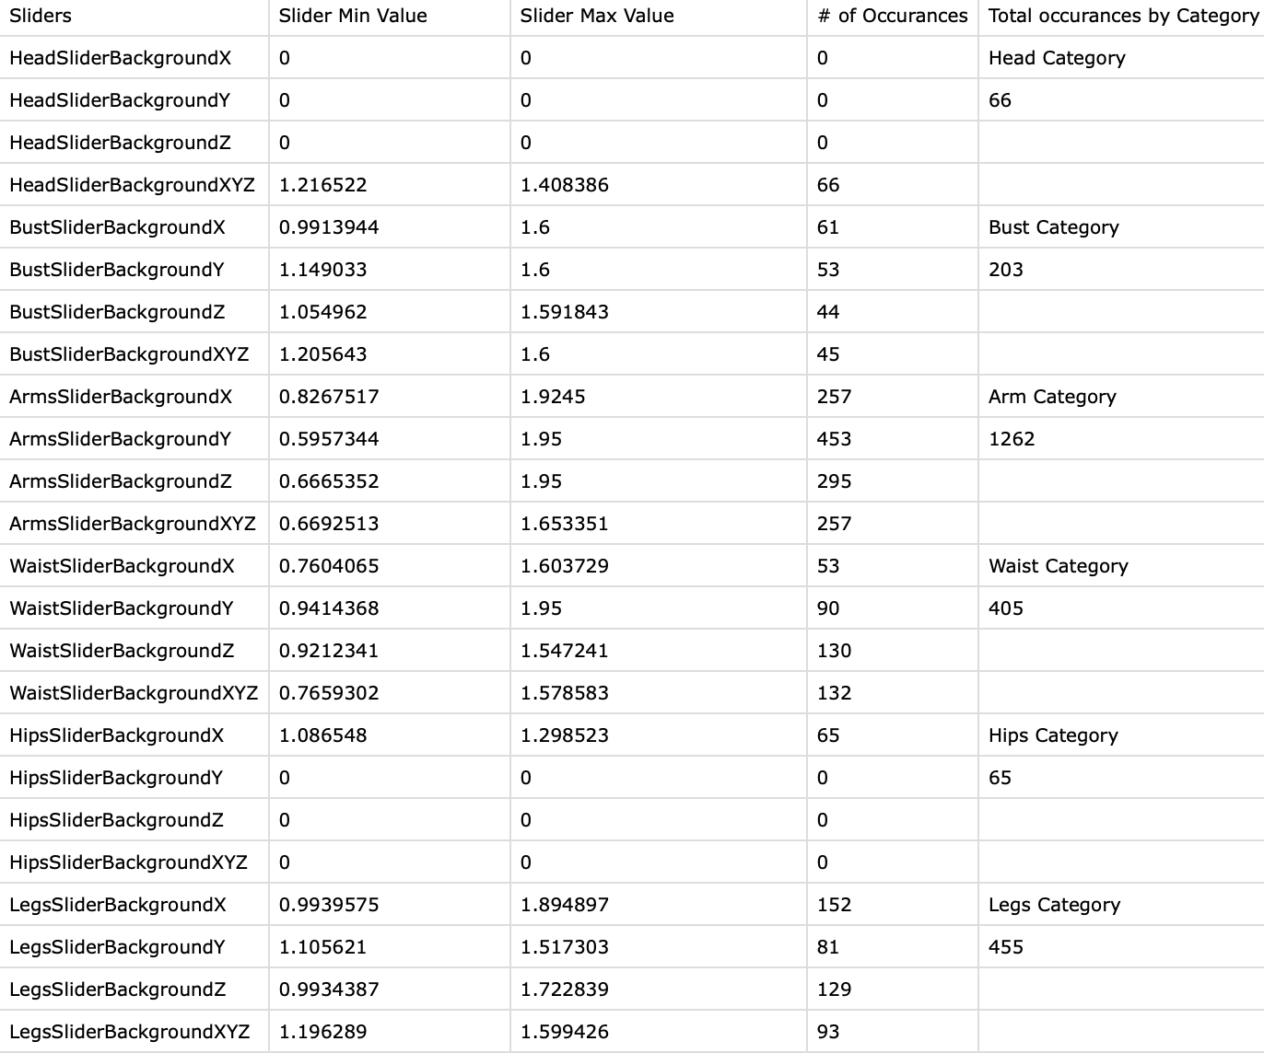

(Table that should be generated)

Some of the formulas that this table uses includes the following *covered by AddSlidersToBottom Code*

* [MINIFS](https://support.microsoft.com/en-us/office/minifs-function-6ca1ddaa-079b-4e74-80cc-72eef32e6599): finds the minimum value of the filtered cells
  + =MINIFS(<entire slider value column>, <entire slider names column>, <sliders name cell in that row>
* [MAXIFS](https://support.microsoft.com/en-us/office/maxifs-function-dfd611e6-da2c-488a-919b-9b6376b28883): finds the maximum value of the filtered cells
  + =MAXIFS(<entire slider value column>, <entire slider names column>, <sliders name cell in that row>
* [COUNTIF](https://support.microsoft.com/en-us/office/countif-function-e0de10c6-f885-4e71-abb4-1f464816df34): finds the number of cells that includes the <string>
  + =COUNTIF(<entire sliders name column>, <slider names cell in that row>
* [SUM](https://support.microsoft.com/en-us/office/sum-function-043e1c7d-7726-4e80-8f32-07b23e057f89): takes the sum of the selected cells (numerical)
  + =SUM(<the cells per category>)

Example usage (fourth row: “HeaderSliderBackgroundXYZ”)

* Slider Min Value = MINIFS(<entire slider value column in CSV>, <entire slider name column in CSV>, “HeaderSliderBackgroundXYZ”) = 1.21
* Slider Max Value = MAXIFS(<entire slider value column in CSV>, <entire slider name column in CSV>, “HeaderSliderBackgroundXYZ”) = 1.40
* # of Occurrences = =COUNTIF(<entire sliders name column>, <”HeaderSliderBackgroundXYZ”> = 66
* Total Occurrences by Category = SUM(<the 4 Head Slider Background Category Cells>) = 66

## ***Tutorial Steps***

1. Download Microsoft Excel
   1. login using your SCU email for free credentials!
2. Download all of the CSV files into your computer
   1. ** Recommended: put all of the csv files into a single folder so it is organized
3. Open all CSV files on excel
   1. On Mac, Shift + Select all > Open with Excel
4. Open VBA on one of the CSV Files
   1. (Excel > Preferences > Ribbon & Toolbar > Customize the Ribbon > Check Developer > Save)
   2. Developer > Visual Basic OR Alt + F11 on Mac
5. Insert code
   1. Insert > Module
   2. Copy Paste the code from below
      1. AddSlidersToBottom(): code that generates the table per participant
      2. ProcessAllOpenCSVFiles(): code that automates this for all open csv files (participant bulks)
6. Close the code
   1. Close the window OR Command + q
7. Run the code
   1. Alt + F8
   2. Select ProcessAllOpenCSVFIles
   3. 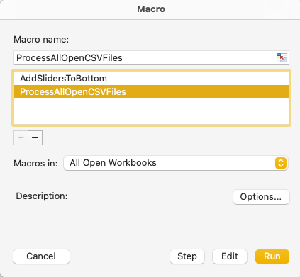
   4. Run
8. All of the selected files should have the table automated! Confirm this by opening one of the files and scrolling to the bottom of that file, if you see a table like the one below (similar is fine, if they all have 0s then something went wrong) then it worked successfully!  
   

## ***Code***

Sub **AddSlidersToBottom()**

Dim ws As Worksheet

Set ws = ActiveSheet ' Process the active sheet

Dim lastRow As Long

lastRow = ws.Cells(Rows.Count, 1).End(xlUp).Row ' Find last row in Column A

' Define slider names

Dim sliders As Variant

sliders = Array("HeadSliderBackgroundX", "HeadSliderBackgroundY", "HeadSliderBackgroundZ", "HeadSliderBackgroundXYZ", _

"BustSliderBackgroundX", "BustSliderBackgroundY", "BustSliderBackgroundZ", "BustSliderBackgroundXYZ", _

"ArmsSliderBackgroundX", "ArmsSliderBackgroundY", "ArmsSliderBackgroundZ", "ArmsSliderBackgroundXYZ", _

"WaistSliderBackgroundX", "WaistSliderBackgroundY", "WaistSliderBackgroundZ", "WaistSliderBackgroundXYZ", _

"HipsSliderBackgroundX", "HipsSliderBackgroundY", "HipsSliderBackgroundZ", "HipsSliderBackgroundXYZ", _

"LegsSliderBackgroundX", "LegsSliderBackgroundY", "LegsSliderBackgroundZ", "LegsSliderBackgroundXYZ")

Dim i As Integer, rowStart As Long

rowStart = lastRow + 2 ' Start inserting data two rows below the last row

' Insert column headers

ws.Cells(rowStart - 1, 1).Value = "Sliders"

ws.Cells(rowStart - 1, 2).Value = "Slider Min Value"

ws.Cells(rowStart - 1, 3).Value = "Slider Max Value"

ws.Cells(rowStart - 1, 4).Value = "# of Occurrences"

ws.Cells(rowStart - 1, 5).Value = "Total Occurrences by Category"

' Get dynamic last row of column C and H (varies per CSV)

Dim lastDataRow As Long

lastDataRow = ws.Cells(Rows.Count, 3).End(xlUp).Row ' Find last row in column C (reference column)

' Insert slider names and formulas

For i = LBound(sliders) To UBound(sliders)

Dim currentRow As Long

currentRow = rowStart + i

ws.Cells(currentRow, 1).Value = sliders(i) ' Insert slider name

' Insert formulas dynamically

ws.Cells(currentRow, 2).Formula = "=MINIFS($H$2:$H$" & lastDataRow & ", $C$2:$C$" & lastDataRow & ", A" & currentRow & ")"

ws.Cells(currentRow, 3).Formula = "=MAXIFS($H$2:$H$" & lastDataRow & ", $C$2:$C$" & lastDataRow & ", A" & currentRow & ")"

ws.Cells(currentRow, 4).Formula = "=COUNTIF($C$2:$C$" & lastDataRow & ", A" & currentRow & ")"

Next i

' Insert category labels and total occurrences formulas

Dim categories As Variant, categoryRow As Long

categories = Array("Head", "Bust", "Arms", "Waist", "Hips", "Legs")

For i = 0 To UBound(categories)

categoryRow = rowStart + (i * 4) ' Every 4 sliders belong to a category

ws.Cells(categoryRow, 5).Value = categories(i) & " Category"

ws.Cells(categoryRow + 1, 5).Formula = "=SUM(D" & categoryRow & ":D" & (categoryRow + 3) & ")"

Next i

MsgBox "Sliders and formulas added successfully!", vbInformation

End Sub

Sub **ProcessAllOpenCSVFiles()**

Dim wb As Workbook

' Loop through all open workbooks

For Each wb In Application.Workbooks

' Check if the workbook is a CSV file

If LCase(Right(wb.Name, 4)) = ".csv" Then

wb.Activate ' Activate the workbook

AddSlidersToBottom ' Run the function

wb.Save ' Save the changes

End If

Next wb

MsgBox "All open CSV files have been processed!", vbInformation

End Sub